Q1 | Write an SQL query to display the total number of songs uploaded by each artist from a table 'songs' (columns: song_id, artist_name, title) and show only those artists who have uploaded more than 3 songs.
Code | SELECT artist_name, COUNT(song_id) AS total_songs FROM songs GROUP BY artist_name HAVING COUNT(song_id) > 3;
Output | 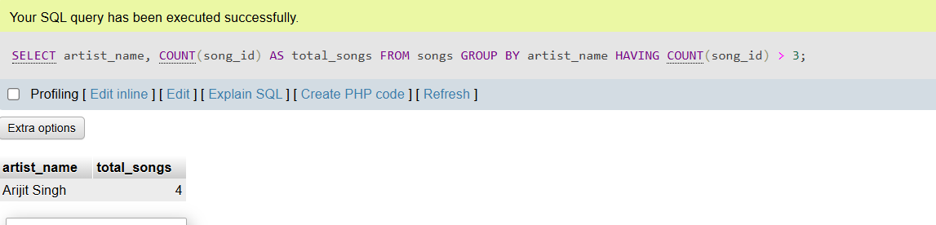

Q2 | Given two tables, 'orders' (order_id, user_id, amount) and 'users' (user_id, username), write a SQL JOIN query to display each username along with their total order amount.
Code | SELECT u.username, SUM(o.amount) AS total_order_amount FROM users u INNER JOIN orders2 o ON u.user_id = o.user_id GROUP BY u.user_id, u.username;
Output | 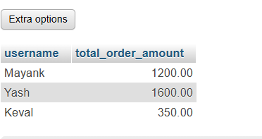

Q3 | Write a SQL subquery to find the names of all restaurants from a 'restaurants' table (id, name, rating) whose rating is higher than the average rating of all restaurants.
Code | SELECT name, average_rating FROM restaurant WHERE average_rating > ( SELECT AVG(average_rating) FROM restaurant );
Output | 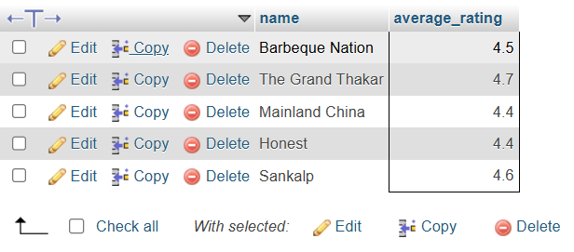

Q4 | Using a 'transactions' table (id, user_id, amount, transaction_date), write a SQL query with a window function to display each user's transaction amount and their running total (cumulative sum) ordered by transaction_date.
Code | SELECT id, user_id, amount, transaction_date, SUM(amount) OVER ( PARTITION BY user_id ORDER BY transaction_date ) AS running_total FROM transactions;
Output | 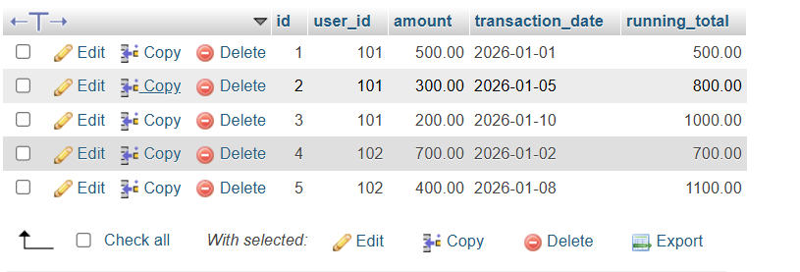

Q5 | List two optimizations you would apply to speed up a query that filters Flipkart products by category and price, and briefly explain how each helps.<br><br><em><strong>Hint:</strong> Think about indexes and query structure.</em>
Code | Create index:  CREATE INDEX idx_category_price ON products3(category, price);  SELECT * FROM products3 WHERE category = 'Mobile' AND price < 30000;  SELECT product_name, price FROM products3 WHERE category='Mobile' AND price < 30000;
Output | 